GCReW Symposium Poster Ideas
- Take a look at synoptic site porewater data and look through the years to see if we are observing increases in specific analytes through time in the transition zones compared to uplands/wetlands.
- Specifically looking at SO4, Cl, H2S, and DOC to see if we are seeing salinization and subsequent DOC release
- Analyses to look at variation through space and time. This would be comparing depths to see if there are significant differences across 10, 20, and 45cm. Also may look at interannual variation - do we see significant differences across years? what about zones?

It looks like maybe SO4/Cl is increasing in the TR at GCW? Missing SWH UP 2025 SO4/Cl data? 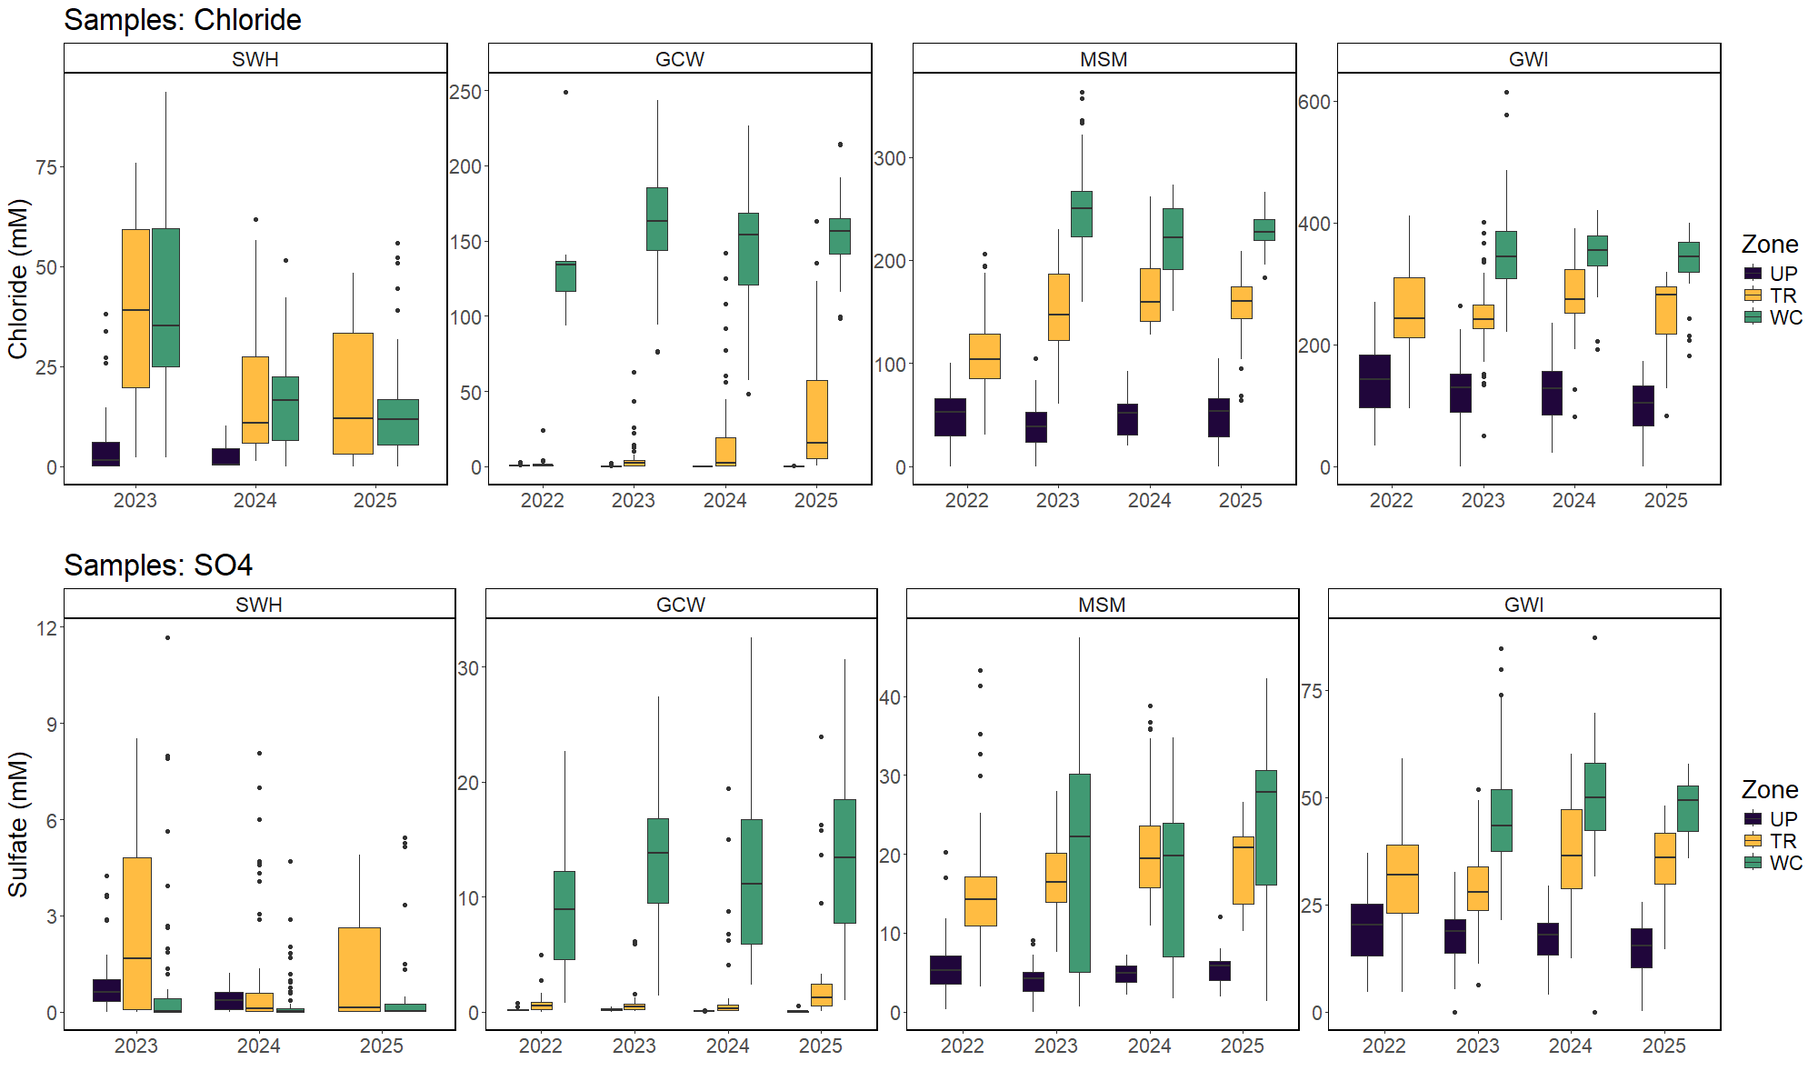

No pattern in H2S data?
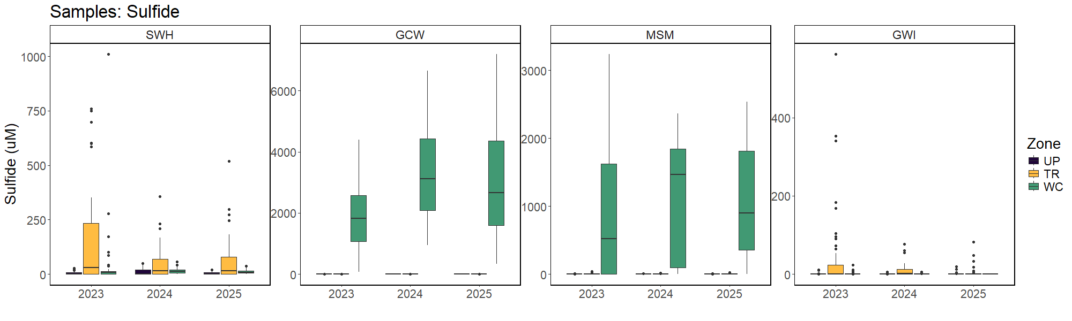

No pattern in DOC data?
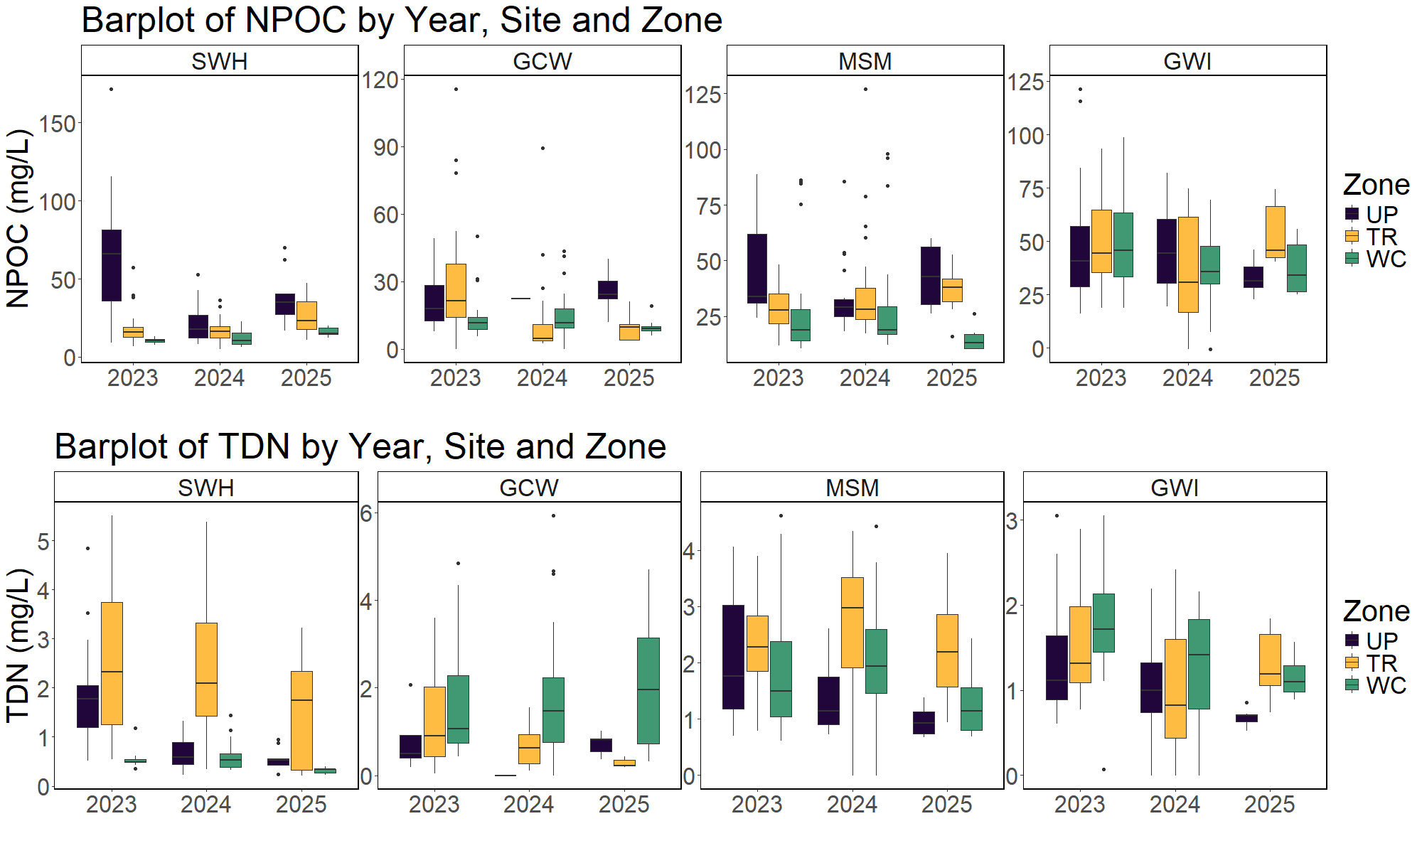

DOC decreases as SO4 increases across Zones?
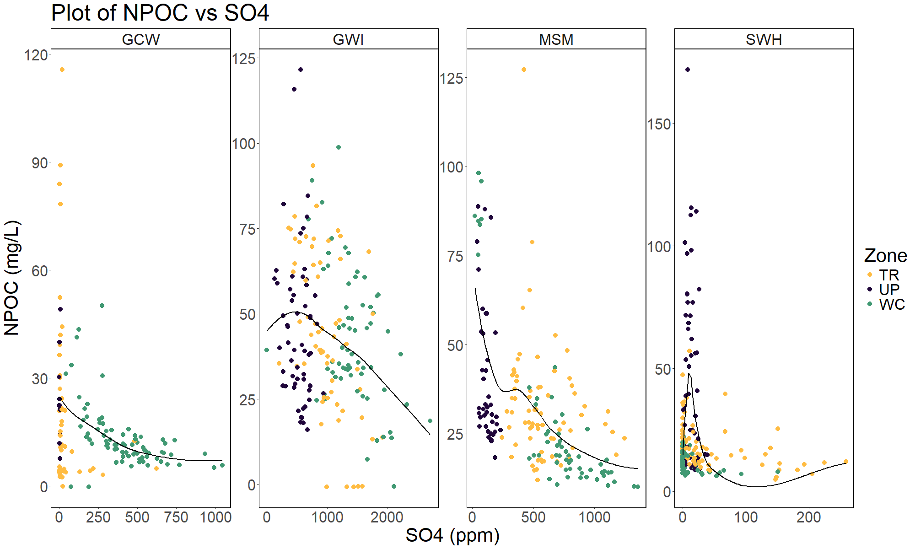

No clear pattern in NPOC vs Cl?
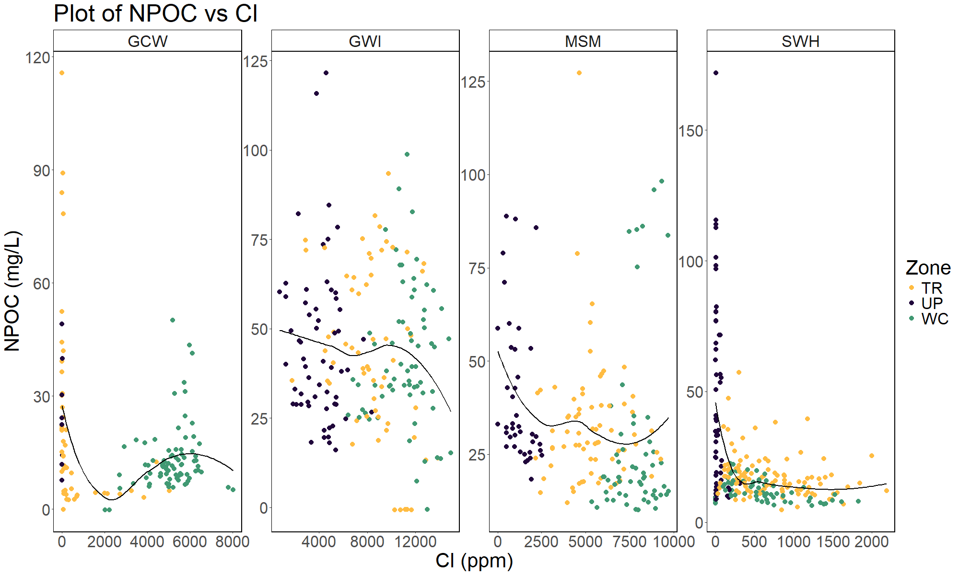

Sulfide, Sulfate, and TDN seem to have the largest differences by depth
